The Context of the Study This research was conducted to explore the historical demographics of the student body at the Augusta Military Academy (AMA). By examining the school’s archival records, we aimed to determine the typical age of students upon their departure and identify whether these patterns shifted during the academy’s long history. To protect the privacy of the former students and their families, it is important to note that this study uses anonymized data. While the dates and identification numbers are historically accurate, all last names have been replaced with randomized placeholders to ensure the confidentiality of the individuals involved.
An Overview of the Records The analysis relied on a dataset containing several key features from the academy’s history, including the students’ names, unique identification numbers, years of departure, and recorded birth information. Because historical archives often contain shorthand or varied notation, several specific assumptions were made to standardize the information for analysis. For example, any year marked with an "S" was interpreted as a summer graduation, and two-digit entries (such as "48") were standardized as 20th-century dates (1948). Furthermore, to ensure the findings remained focused on the actual student experience, the data was filtered to include only individuals between the ages of 7 and 23. This range reflects the historical reality of the academy’s enrollment while removing potential data-entry errors from the archives.
Visualizing the Historical Trends
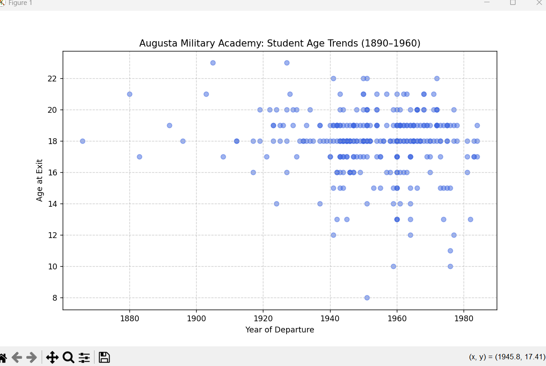
Observations and Conclusions The resulting data provides a compelling look at how the academy’s student profile evolved over nearly a century. As seen in the visualization above, there is a distinct change in the consistency of student ages over time. In the late 19th and early 20th centuries, the age at which students left the academy varied significantly. Some students departed as young as 10 or 11, while others remained into their early twenties, suggesting that the academy originally served a much broader range of educational levels.
However, as the institution moved through the 1940s and toward the 1960s, the data points begin to cluster much more tightly. By the mid-20th century, the vast majority of cadets were departing between the ages of 17 and 19. This visual trend indicates that AMA successfully transitioned from a varied multi-level school into a standardized secondary institution focused on college preparation. This shift reflects broader national trends in American education, where school stages became more strictly defined by age and grade level as the century progressed.

